**2020**

**VCE**

**Mathematical Methods**

**Trial Examination 1**

**Detailed Answers**



|  |  |
| --- | --- |
| **Kilbaha Education Publishing**  **PO Box 2227**  **Kew Vic 3101**  **Australia** | **Tel: (03) 9018 5376**  **Fax: (03) 9817 4334**  [**kilbaha@gmail.com**](mailto:kilbaha@gmail.com)  [**https://kilbaha.com.au**](https://kilbaha.com.au) |

*All publications from Kilbaha Education are digital and are supplied to the purchasing school in both WORD and PDF formats with a school site licence to reproduce for students*

*in both print and electronic formats.*



|  |  |
| --- | --- |
| **Kilbaha Education (Est. 1978) (ABN 47 065 111 373)**  **PO Box 2227**  **Kew Vic 3101**  **Australia** | **Tel: +613 9018 5376**  **Fax: +613 9817 4334**  **Email:** [**kilbaha@gmail.com**](mailto:kilbaha@gmail.com)  **Web:** [**https://kilbaha.com.au**](https://kilbaha.com.au) |

**IMPORTANT COPYRIGHT NOTICE FOR KILBAHA PUBLICATIONS**

(1) The material is copyright. Subject to statutory exception and to the provisions of the relevant collective licensing agreements, no reproduction of any part may take place without the written permission of Kilbaha Pty Ltd.

(2) The contents of these works are copyrighted. Unauthorised copying of any part of these works is illegal and detrimental to the interests of the author(s).

(3) For authorised copying within Australia please check that your institution has a licence from <https://www.copyright.com.au> This permits the copying of small parts of the material, in limited quantities, within the conditions set out in the licence.

(4) All pages of Kilbaha files must be counted in Copyright Agency Limited (CAL) surveys.

(5) Kilbaha files must **not** be uploaded to the Internet.

(6) Kilbaha files may be placed on a password protected school Intranet.

**Kilbaha educational content has no official status and is not endorsed**

**by any State or Federal Government Education Authority.**

While every care has been taken, no guarantee is given that the content is free from error.

Please contact us if you believe you have found an error.

**CAUTION NEEDED!**

All Web Links when created linked to appropriate Web Sites. Teachers and parents must always check links before using them with students to ensure that students are protected from unsuitable Web Content. Kilbaha Education is not responsible for links that have been changed in its publications or links that have been redirected.

**Question 1**

**a.**  using the chain rule



 M1



 A1

**b.i.** 

 A1

**ii.** 

 A1

**Question 2**

**a.**  completing the square

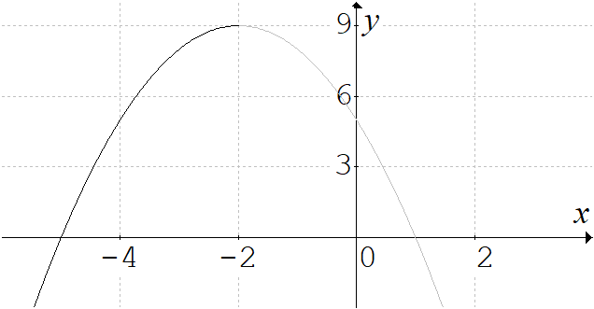 

for the function *f* to be a one-one function

dom  A1

**b.** 

 ,  M1

take the negative sign, since ran  and dom

to state the function, we must state the domain

 A1

**Question 3**

rearranging to make *y* the subject

 M1

gradients are equal when 

 A1

the *y* intercepts are  and  , when , the *y*-intercepts are equal,

when  or , the *y*-intercepts are different.

**i.** a unique solution, when . A2

**ii.**  infinitely many solutions when .

**iii.**  no solution when  or .

**Question 4**

 , differentiating using the quotient rule



 for stationary points A1

 M1

the coordinate is  A1

**Question 5**

**a.** 

 , domain  A1

**b.** crosses the *x*-axis,  , 

crosses the *y*-axis,  ,

vertical asymptote , horizontal asymptote  G2



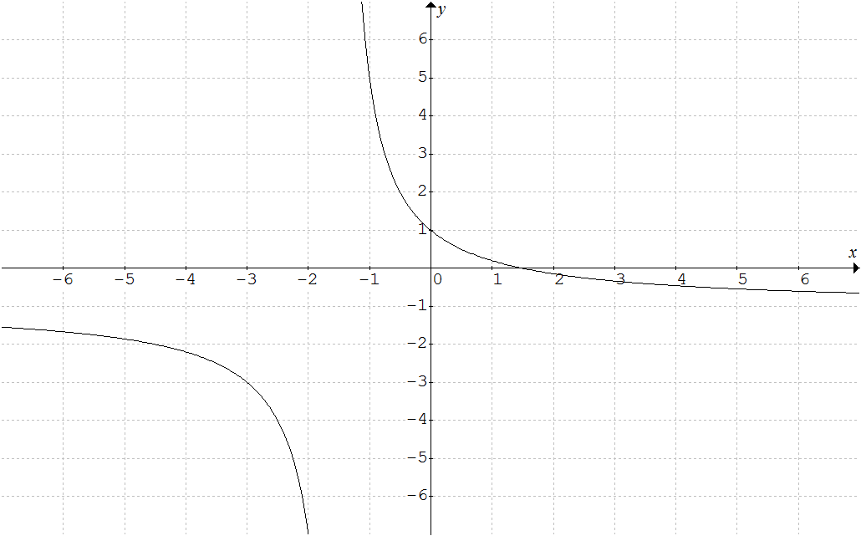







**c.** Since the area is below the *x*-axis, the area is



 A1  A1

**Question 6**

**a.** original curve , the image curve

 M1



 , so that  A1

**b.** reflect in the *x*-axis

dilate by a factor of 6 parallel to the *y*-axis ( or away from the *x*-axis )

dilate by a factor of parallel to the *x*-axis ( or away from the *y*-axis ) A2

translate 3 units up, parallel to the *y*-axis ( or away from the *x*-axis )

**c.** , the period , the range is 

endpoints, 

maximum value of 9, occurs when , 

 , . Note that  and ,

minimum value of  occurs when , 

crosses the *x*-axis when 

 ,  ,  ,  G2





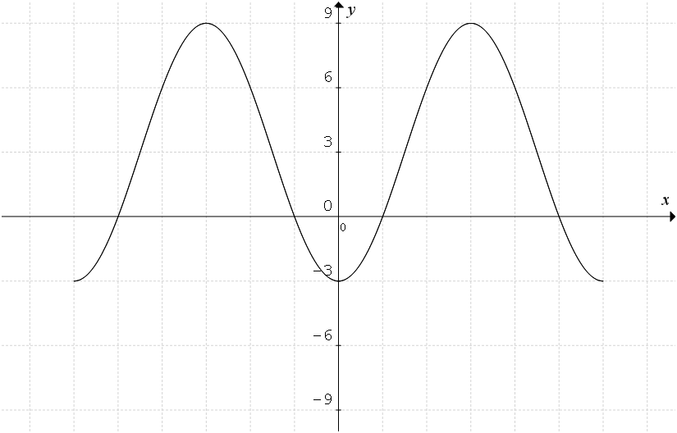























**Question 7**



|  |  |  |  |
| --- | --- | --- | --- |
|  |  |  |  |
|  |  |  |  |
|  |  |  |  |
|  |  |  |  |

## 

A1

since all are probabilities, we require  , **, 

and ** now these are all satisfied for  and , since 

, now  so  M1

and , now  so  so that

 or  A2

**Question 8**

**a.**  using the product rule



 A1

**b.** 

 from part **a.** A1



 A1

**Question 9**



 M1



 A1

 M1



 A1

**Question 10**

**a.** Let , consider the tangent at the point 



the tangent is 

since this tangent passes through the origin,  and  M1



The tangent which passes through the origin is  A1

**b.** Hence the equation , has exactly

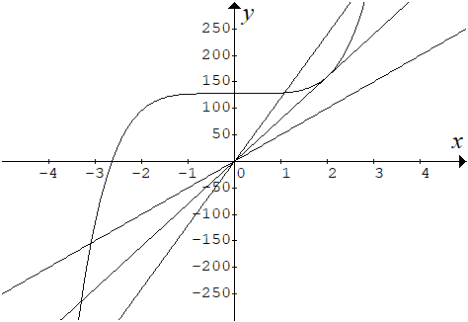

**i.** one real solution when 

**ii.** exactly two real solutions 

**iii.** exactly three real solutions 

**iv.** there are no real values of *k*, A2

for exactly four real solutions.

##### End of detailed answers for the

##### 2020 Kilbaha VCE Mathematical Methods Trial Examination 1

|  |  |
| --- | --- |
| **Kilbaha Education Publishing**  **PO Box 2227**  **Kew Vic 3101**  **Australia** | **Tel: (03) 9018 5376**  **Fax: (03) 9817 4334**  [**kilbaha@gmail.com**](mailto:kilbaha@gmail.com)  [**https://kilbaha.com.au**](https://kilbaha.com.au) |